Classification of TerraSAR-X imagery for the characterization of Amazon tropical forests

J. R. Santos⁽¹⁾; J.C. Mura⁽¹⁾; H.J.H. Kux⁽¹⁾, C. E. Garcia⁽¹⁾; S. Kuntz⁽²⁾;
I.F. Brown⁽³⁾; N.V. Pantoja⁽¹⁾

(1) National Institute for Space Research – INPE
Av. dos Astronautas 1758, 12227-010 S.J.Campos -SP - Brazil, jroberto@dsr.inpe.br
(2) Infoterra GmbH
88039 Friedrichshafen, Germany, steffen.kuntz@infoterra-global.com
- Federal University of Acre – UFAC
Rodovia BR 364, Km 04 69915-900 Rio Branco -AC- Brazil, fbrown@uol.com.br

Abstract. The objective of this study is to analyze the potential of TERRA SAR-X dual images, on the StripMap mode, for classification of forest cover and of land use classes resulting from human activities. The area under study is located in the portions of SW Brazilian Amazon region, Acre State. The StripMap images of TerraSAR-X, dual polarization, were processed in accordance with the following methodological steps: (a) generation of the covariance matrix; (b) application of the Enhanced Lee filter to reduce the speckle noise; (c) targets decomposition technique based on the Cloude and Pottier theorem; (d) thematic classification by algorithm MLC + ICM (Maximum Likelihood Classifier + Iterated Conditional Modes); (e) assessment of classification accuracy by Kappa statistics. This approach has shown the potential of TerraSAR-X images for the discrimination of primary forest, degraded forest, pastures and agricultural areas/bare soil. The best classification was derived from the combination of the image resulting from the amplitude components of the covariance matrix and the entropy image generated from the target decomposition theorem. The overall classification accuracy was 76% and the Kappa value of 0.67, whose analysis were supported by field survey realized simultaneously to the acquisition of the radar images. The state of art of the forest conditions analyzed by X-band radar imagery will be an important tool, together with other frequencies/SAR systems, to subsidize both the inventory and monitoring processes of land use/land cover in Brazilian Amazon.

Keywords: monitoring, tropical forest, image processing, SAR data, land cover.

Introduction

The generation of land use and land cover classification maps in tropical area is a typical application in remote sensing using optical satellite data. Due to the relative independence of weather conditions, the past decades have also seen considerable efforts of research done on the use of microwave systems for mapping, inventory and monitoring forest landscape.

To briefly introduce a reader on the concepts and applications of radar data in land cover types, the following papers we recommended: [1] studied multi-polarimetric SAR backscatter for the discrimination of land cover types, discussing those aspects of scattering and attenuation of SAR signals at different frequencies interacting with structural parameters of targets; [2] comparing the use of high resolution SAR images (X, C, L and P-bands) in different polarizations for the classification of tropical forest types and non-forest, report one performance accuracy of classification of 63% using X-band data and classification results of up to 88% using three SAR frequency and polarizations combinations; [3] and [4] correlated information obtained from radar with vegetation biophysical parameters, discussing the saturation of backscatter caused by the high density of tropical forests; Power spectrum analysis was made using autoregressive moving-average (ARMA) models, for evaluation of forest canopy structure from airborne SAR (X–band) data in the Brazilian Amazon [5]; the discrimination of recent deforestation from others land cover classes was evaluated by [6], utilizing the L-band airborne SAR polarimetric images; the Iterated Conditional Mode (ICM) contextual classifier was applied by [7] into amplitude, intensity and some polarimetric attributes (entropy, alpha angle) extracted from SAR data (P-band) to generate land cover mapping with considerable thematic accuracy. The above mentioned studies exemplify the importance of radar spectra match those obtained from ground data, establishing the basis for the mapping and monitoring the tropical landscape.

With the launch of TerraSAR-X in June 2007, at a public-private partnership between the German Aerospace Center (DLR) and EADS Astrium, the user community got new SAR products as analysis tools for the landscape analysis, specially considering its high geometrical resolution.

Within this frame, the main objective of this work is to analyze the potential of Terra-SAR-X dual images, on the StripMap mode, for classification of forest cover and of land use classes resulting from human activities in the SW Brazilian Amazon. In this study we present (1) the SAR response of each land use/ land cover classes and (2) the performance of classification, comparing the target decomposition technique based on Cloude’s theorem and the MAXVER+ICM (Maximum Likelihood Classifier for polarimetric data and Iterated Conditional Modes) technique.

1. TerraSAR-X data sets and methods

The TerraSAR-X operates a synthetic aperture radar and is able to produces high resolution images, in SpotLight, StripMap and ScanSAR modes that results in spatial resolutions varying between 1 and 16m and single and dual polarization [8]. High resolution StripMap mode data were acquired in 24th June, 2009, over the Sena Madureira region, Acre State, Brazil (9° 00´ e 9° 45´ S and 68° 00´ – 68° 35´ W), with the following characteristics: ascending mode, HH and VV polarizations, slant range resolution of 1.125m, azimuth resolution of 6.59m, and incident angle of 43.460° (near) to 44.610° (far).

The dual polarization images, provides in SLC format, were first pre-processed using POLSARPRO 4.02 tool to generate the covariance matrix with a window size of 12x2 pixels in range and azimuth direction, respectively, and applying the Enhanced Lee filter algorithm, with a window size of 5x5 pixels, to minimize speckle noise. The resulting data were classified using two techniques: one due to Cloude’s target decomposition theorem and another, the statistical approach based on the contextual MAXVER+ICM classifier, developed by [9] for polarimetric SAR data.

The conceptual base of target decomposition was developed for SAR QuadPol data [10], but it can also be applied to dual-polarized data [11]. The Cloude decomposition is capable of describing a whole range of scattering mechanisms, based on the eigenvector analysis of the coherence matrix [T]. The Cloude’s entropy (H) is calculated from the eigenvalues of [T] derived from the covariance matrix [C]. By using HH and VV polarizations the covariance matrix components can be represented by <<HH²>>, <<VV²>> and the cross product <<HHVV>>, where <<>> represents a spatial average. The cross product has the information of the phase difference between HH and VV channels. These three components as well those derived from the Cloude’s decomposition (entropy, anisotropy and alpha angle) were used as the input of the classification procedure.

The statistical classification tool used in this work is based on a statistical decision rule that examines the (Bayesian) Probability Density Function calculated from the inputs for classes established from training sites, and assigns the pixel to the class with the highest probability (Maximum Likelihood Classifier). In order to improve the homogeneity of the classes a pos-classification process called the Iterated Conditional Modes (ICM) was applied. The ICM algorithm is a contextual procedure that, in order to classify each pixel, uses both the observed value in the corresponding coordinate and the classification of the surrounding sites. The combination tools, MAXVER+ICM, was adapted [9] to deal with appropriated Probability Density Function of the SAR data represented by amplitude, intensity and covariance matrix [C].

The TerraSAR-X image covering the area under study was classified by the above described techniques, isolated and combined, in order to generate the land use/land cover map with the best performance. Considering a combined classification, we tested the contribution of the “entropy” component, derived from Cloude's target decomposition theorem, together with the amplitude of the co-variance matrix elements (CHH, CVV, CHV) using the MAXVER+ICM algorithm. The classification performance of all these resulting products was evaluated by Kappa statistics with previously obtained and geo-referenced information from field survey.

2. Results and Discussions

In the western part of the Amazon region, subsistence agriculture for the production of rice, beans and cassava, occupies a significant part of small properties. Nevertheless in the region surrounding Sena Madureira, there are extensive areas of pasture for cattle raising, even on dissected terrain with flat tops. Areas degraded by timber exploitation and also succession stages due to the abandonment of the traditional use as a consequence of loss of soil fertility. Based on the exploratory analysis one observes at Fig. 1 the characteristic behavior of the radar response for land use/land cover classes. At this profile the standard deviation of the SAR response was higher at forest targets than at agricultural/pasture classes. A similar result was found also by [12]. Primary forest borders were generally distinguished from other land cover classes, except for degraded forest. At this figure the response of HH and VV polarizations are quite similar; the use of an additional cross-polarized image would probable help to improve the separation among land use/land cover classes, due to scattering mechanisms which command the interaction of the X-band signal with the targets.

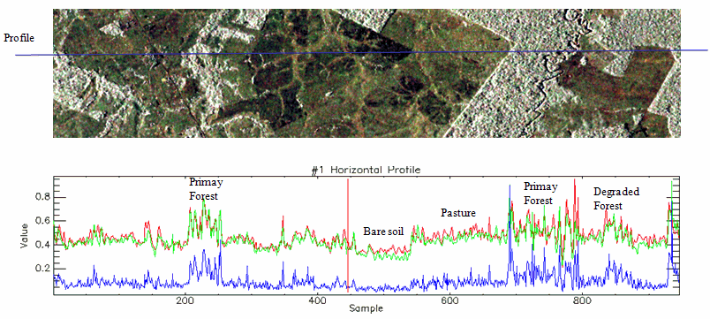
Figure 1. TerraSAR-X image profile and equivalent multi-polarized responses of the landscape. Image composite: HH(red), VV (green) and HHxVV(blue) polarizations.

At the analysis of isolated and combined classifications, the best one was obtained using the MAXVER+ICM algorithms, considering both the amplitude of the covariance matrix elements plus the entropy data, derived from Cloude’s target decomposition (Figure 2). The use of entropy information improves the discrimination of the primary forest classes. At Table 1 one can observe the performance of this SAR attribute integration in the image classification procedure. The Kappa value found was 0,668 and it corresponds to a “substantial agreement” at the performance table established by [13].

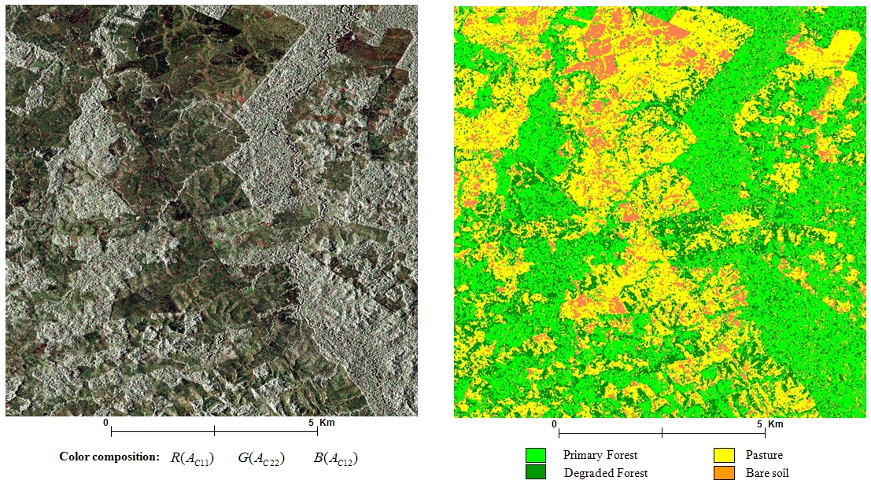

Figure 2. TerraSAR-X composite image of the amplitude components from the co-variance matrix (left); land use/land cover classification obtained by co-variance matrix elements + entropy (right).

Table 1. Classification performance by MAXVER + ICM algorithm using amplitude of the covariance matrix plus the entropy.

Classes | Primary Forest | Pasture | Degraded Forest | Bare soil
Primary Forest | 88.58% | 0.57% | 10.785 | 0.055%
Pasture | 4,35% | 72,98% | 20.80% | 1.82
Degraded Forest | 27.72% | 5.20% | 67.01% | 0.051%
Bare soil | 3.62% | 17.32% | 0.41% | 78.73
Kappa = 0.668 |  | Kappa variance = 3.99425e-6
Overall Accuracy(%) = 76.04 |  | Overall Error (%) = 23.95

The effect of geomorphologic variable “slope” in the TerraSAR-X response could also be responsible for the accuracy reduction in the classification, besides specific characteristics of each target studied.

3. Conclusions

In this study using a StripMap image from TerraSAR-X the results indicate that it is possible to discriminate forest from other land cover and land use targets. The discrimination of these landscape aspects was improved with the use of the coherent attribute “entropy” as a component of the classification model, because it is associated to the degree of randomness of the scattering process, which defines the target.

Using other classifiers which consider textural SAR attributes in such high resolution images (X-band), would help to advance landscape studies with TerraSAR-X images in the Brazilian Amazon. The results obtained indicate the potential of TerraSAR-X data for the assessment and monitoring of tropical forests.

Acknowledgments

This study was developed in the frame of a technical cooperation agreement between INPE and INFOTERRA. We acknowledge also CNPq for the concession of research grants and to CAPES-PROCAD for the academic cooperation with UFAC.

References

[1] Hendersen, F. M.; A. J. Lewis. Radar fundamentals: The geoscience perspective. In: Ryerson, R.A. ed., Principles & Applications of Imaging Radar. Manual of Remote Sensing, 3. ed. New York, John Wiley & Sons, Inc., vol.2, cap.3, p.131-181. 1998

[2] Van der Sanden, J.; D. Hoekman. Potential of airborne radar to support the assessment of land cover in a tropical rain forest environment. Remote Sensing Environment, 68:26-40. doi:10.1016/S0034-4257(98)00099-6. (1999)

[3] Hoekman, D. H.; M. J. Quinones. Land cover type and biomass classification using AirSAR data for evaluation of monitoring scenarios in the Colombian Amazon, IEEE Trans. Geoscience and Remote Sensing, 38 (2): 685–696. (2000)

[4] Santos, J. R.; M. S. Pardi Lacruz; L. S. Araujo; M. Keil. Savanna and tropical rainforest biomass estimation and spatialization using JERS-1 data. International Journal of Remote Sensing, 23(7):1217-1229. (2002)

[5] Neeff, T. ; L.V. Dutra ; J.R Santos; C.C. Freitas; L. S. Araujo. Power spectrum analysis of SAR data for spatial forest characterization in Amazonia. International Journal of Remote Sensing, 26(13): 2851-2865. (2005)

[6] Santos, J. R.; J. C. Mura; W. R. Paradella, L. V. Dutra; F. G. Gonçalves. Mapping recent deforestation in the Brazilian Amazon using simulated L-band MAPSAR images. International Journal of Remote Sensing, 29(16): 4879 - 4884. (2008)

[7] Freitas, C. C.; L. S. Soler; S. J. S. Sant’Anna; L. V. Dutra; J. R. Santos; J. C. Mura; A. H Correia. Land use and land cover mapping in the Brazilian Amazon using polarimetric airborne P-band SAR data. IEEE Transactions on Geoscience and Remote Sensing, 46(10): 2956 – 2970. (2008)

[8] DLR. TerraSAR-X – The German radar eye in space. Mission Brochure. http://www.dlr.de/Portaldata/1/Resources/forschung_und_entwicklung/missionen/terrasar_x/TSX_brosch.pdf. (2007)

[9] Correia, A.H. Projeto, desenvolvimento e avaliação de classificadores estatísticos pontuais e contextuais para imagens SAR polarimétricas. Dissertação de Mestrado em Sensoriamento Remoto, Instituto Nacional de Pesquisas Espaciais- INPE, São José dos Campos, 1998. 271p. (INPE-7178-TDI/679). Disponível em: http://urlib.net/sid.inpe.br/deise/1999/09.14.14.45. Acesso em: 12fev., 2010.

[10] Cloude, S. R.; E. Pottier. An entropy based classification scheme for land application of polarimetric SAR. IEEE Transactions on Geoscience and Remote Sensing, 35(1): 68-78. (1997)

[11] Cloude, S.R. The dual polarization entropy/alpha decomposition: a PALSAR case study. In: POLinSAR Workshop, June 22-26th, 2007. Frascati, Italy. ESA. Abstract Book. p.19. (2007)

[12] Breidenbach, J.; S.M.Ortiz.; M. Reich. Forest monitoring with TerraSAR-X: first results. European Journal of Forest Research, (Springer-Verlag). Published online: 19 nov., 2009. DOI 10.1007/s10342-009-0318-y. (2009)

[13] Landis, J.R.; G.G. Koch. The measurement of observer agreement for categorical data. Biometrics, 33: 159-174. (1977)

